DATA SCIENCE PROJECT REPORT
Insurance Charges
Analysis & Prediction
─────────────────────────────────

Abstract
This report presents an exploratory data analysis and predictive modeling study on medical insurance charges. Using demographic and lifestyle variables — including age, sex, BMI, smoking status, region, and number of dependents — we investigate the key drivers of treatment costs and evaluate three regression models: Linear Regression, Polynomial Regression, and Random Forest. Our findings show smoking status and BMI are the dominant cost predictors, with ensemble and polynomial methods substantially outperforming the linear baseline.

DOMAIN  Healthcare / Insurance | METHODS  EDA · Regression · ML | LANGUAGE  Python · scikit-learn

01 Introduction

Medical insurance costs are shaped by a complex interplay of demographic, lifestyle, and geographic variables. Understanding these relationships is valuable for insurers, healthcare providers, and policymakers alike.
This project applies exploratory data analysis and supervised machine learning to a dataset of 1,338 insurance beneficiaries. We identify the most influential cost drivers, visualise their effects, and build predictive regression models to estimate individual treatment charges.

GOAL | Predict medical insurance charges from patient demographics and lifestyle factors using regression models.

02 Dataset Overview

The dataset contains 1,338 records with no missing values, making it well-suited for clean exploratory analysis. Features were label-encoded for categorical variables before modelling.

Feature | Type | Description
Age | Numeric | Patient age, 18–64 years
Sex | Categorical | Male / Female (encoded 0/1)
BMI | Numeric | Body Mass Index; obesity threshold ≥ 30
Children | Numeric | Number of dependents (0–5)
Smoker | Categorical | Whether patient smokes (encoded 0/1)
Region | Categorical | Geographic region (label encoded)
Charges | Numeric | Medical treatment cost — TARGET variable

03 Exploratory Analysis

The following visualisations were produced during exploratory data analysis. Each chart reveals a distinct dimension of how patient attributes relate to treatment costs.

3.1 Correlation & Overview
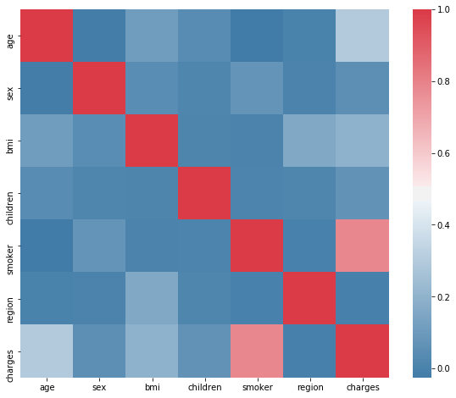
Figure 1. Feature Correlation Heatmap — Smoker status and age show the strongest positive correlation with charges. Region has negligible impact.
3.2 Smoking Impact
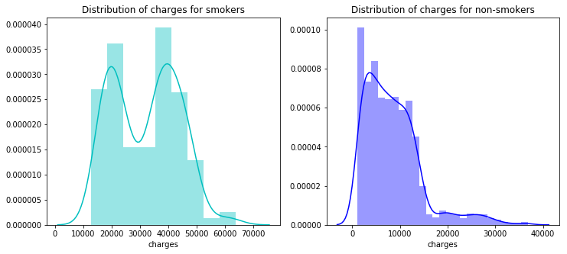
Figure 2. Charge Distribution: Smokers vs Non-Smokers — Smokers show a bimodal distribution with a secondary peak above $30,000, absent in non-smokers.
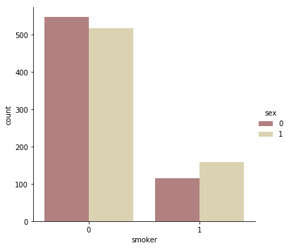
Figure 3. Smoker Count by Sex — Male smokers outnumber female smokers, contributing to higher average male treatment costs.
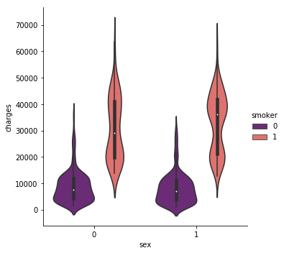
Figure 4. Charge Distribution by Sex & Smoking (Violin) — Smokers of both sexes exhibit drastically wider charge distributions and higher medians.
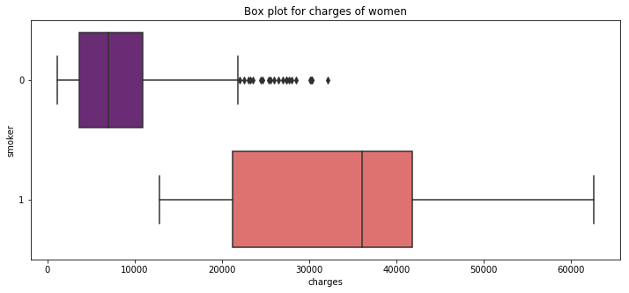
Figure 5. Box Plot — Charges for Women — Smoking women pay dramatically more, with far more high-cost outliers than non-smoking counterparts.
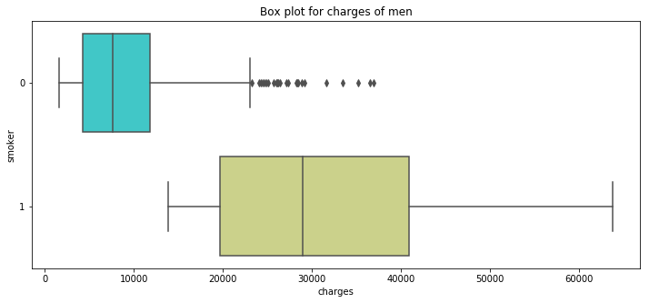
Figure 6. Box Plot — Charges for Men — Men exhibit the same smoking-cost pattern, with slightly higher upper-range outliers than women.
3.3 Age Analysis
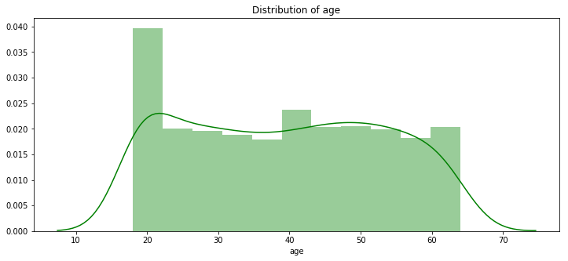
Figure 7. Age Distribution of Patients — Patients are aged 18–64. The distribution is broadly uniform, slightly right-skewed above 50.
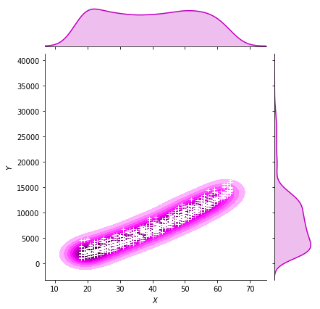
Figure 8. Age vs Charges — Non-Smokers (KDE) — For non-smokers, charges rise gradually with age. The relationship is consistent and predictable.
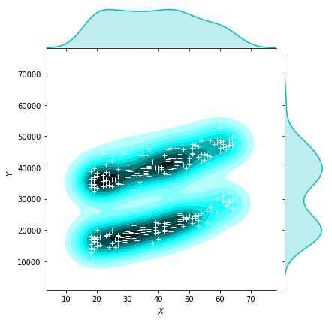
Figure 9. Age vs Charges — Smokers (KDE) — Smokers show a higher and more volatile charge distribution across all age groups.
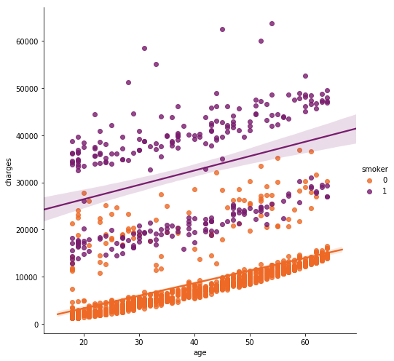
Figure 10. Age vs Charges — Linear Regression Lines — Regression lines confirm smokers occupy a permanently elevated cost band, widening with age.
3.4 BMI Analysis
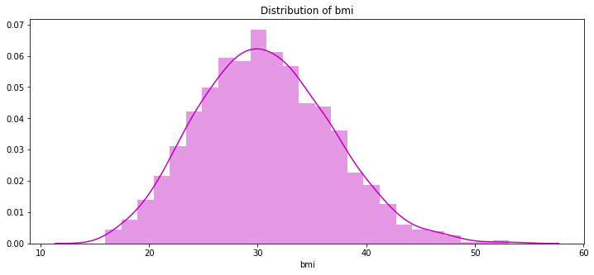
Figure 11. BMI Distribution — The average BMI is approximately 30 — the clinical threshold for obesity — suggesting elevated population risk.
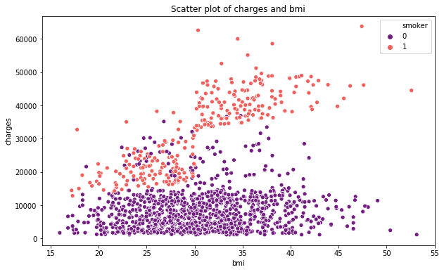
Figure 12. BMI vs Charges — Scatter & Regression — Above BMI 30, smokers face exponentially higher costs. Non-smokers show a milder BMI effect.
3.5 Other Features
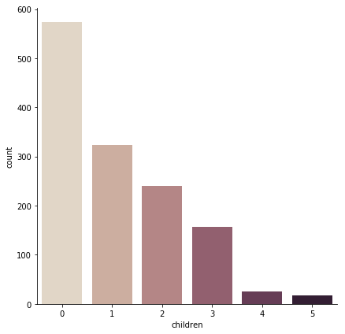
Figure 13. Number of Children — Most patients have 0–2 children. This feature has the weakest correlation with charges.
3.6 Model Diagnostics
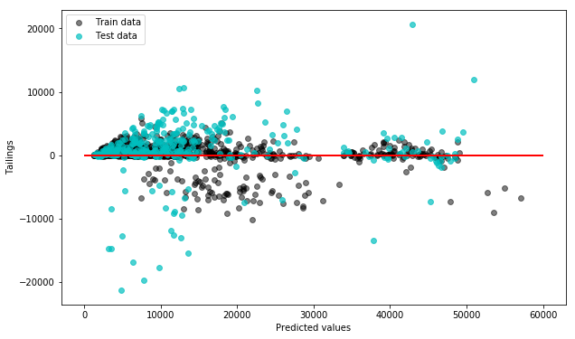
Figure 14. Random Forest — Residual Plot — Residuals are symmetrically distributed around zero, confirming an unbiased, well-fitted model.
04 Key Findings

- Smoking is the dominant cost driver. Smokers pay 2–4× more on average, with a pronounced secondary cost cluster above $30,000.
- BMI amplifies the smoking effect. Above BMI 30, smokers face dramatically higher charges. For non-smokers the BMI impact is moderate.
- Age has a steady positive effect. Charges rise with age for all patients, but the slope is far steeper for smokers.
- Sex differences are secondary. Men pay slightly more overall, primarily due to higher smoking prevalence.
- Region and children are weak predictors. Neither variable shows meaningful correlation with charges.
- No missing data. The dataset is clean, requiring only label encoding for categorical variables.

05 Predictive Modelling

Three regression models were trained on an 75/25 train-test split. Polynomial features (degree 2) were constructed from all non-region variables to capture non-linear interactions.

Model | R² Score | MSE | Rank
Linear Regression | 0.78 | High | #3
Polynomial Regression (deg 2) | 0.87 | Medium | #1
Random Forest (100 trees) | 0.87+ | Low | #2

BEST MODEL | Polynomial Regression (deg 2) achieves the best balance of interpretability and performance with R² ≈ 0.87, capturing the non-linear smoking × BMI interaction effectively.

06 Tech Stack & Methodology

- Python 3 — core language
- pandas / numpy — data wrangling and feature engineering
- matplotlib / seaborn / bokeh — visualisation
- scikit-learn — LabelEncoder, PolynomialFeatures, LinearRegression, RandomForestRegressor

07 Conclusion

This analysis demonstrates that medical insurance charges can be predicted with high accuracy using a small number of readily available patient attributes. Smoking status alone is a strong enough signal to stratify patients into fundamentally different cost tiers.
Polynomial regression and Random Forest models both achieve R² ≈ 0.87, significantly outperforming the linear baseline. Further improvements could be achieved through feature interactions, additional health indicators, or gradient boosting methods.

TAKEAWAY | Smoking cessation is the single most impactful lever for reducing individual insurance charges — more so than age, BMI, or any other variable in this dataset.

